**IndiraGandhiDelhiTechnicalUniversityfor Women**

**(EstablishedbyGovt.ofDelhivideAct09of2012)**

**(FormerlyIndira GandhiInstitute of Technology)**

** KashmereGate,Delhi -110006**

|  |  |
| --- | --- |
|  |  |

**LABORATORY FILE**

**FOR**

**Machine Learning**

**MCA-IT(1st year)**

**Submitted to: Submitted by:**

**Ms.Anjum Shweta Rawat**

**06304092023**

| **S.NO.** | **EXPERIMENT** | **DATE** | **SIGN** |
| --- | --- | --- | --- |
| 1. | 1. WAP to create a List for any five subjects of your semester.  2. WAP to create Tuples for any five subjects of your semester.  3. WAP to create a Dictionary for the marks of each subject. | 29/03/2024 |  |
| 2. | WAP to explore various functions in the Math library in python. | 29/03/2024 |  |
| 3. | WAP to print various types of graphs using Matplot library of python | 29/03/2024 |  |
| 4. | WAP to explore various functions in Numpy library of python. | 03/04/2024 |  |
| 5. | WAP to Perform Data Preprocessing Functions on The Data Set publically Available | 04/04/2024 |  |
| 6. | Write a program to demonstrate Single Linear Regression using Numpy, Matplot and Panda Library. | 14/04/2024 |  |
| 7. | Write a program to demonstrate Multiple Linear Regressions using Numpy, Matplot and Panda Library. | 14/04/2024 |  |
| 8. | Write a program to demonstrate Logistic Regression using Numpy, Matplot and Panda Library. | 21/04/2024 |  |
| 9. | Write a program to demonstrate Multiple Logistic Regressions using Numpy, Matplot and Panda Library. | 21/04/2024 |  |
| 10. | Write a program to demonstrate Decision Tree using any dataset from Kagle using scikit-learn, Numpy, Seaborne/ Matplot and Panda Library. | 21/04/2024 |  |
| 11. | Write a program to demonstrate Naïve Bayes Classifier using any dataset from Kagle using scikit-learn, Numpy, Seaborne and Panda Library. | 21/04/2024 |  |
| 12. | WAP to demonstrate Random Forest Ensemble. | 21/04/2024 |  |

**Q1)**

**1. WAP to create a List for any five subjects of your semester.**

**2. WAP to create Tuples for any five subjects of your semester.**

**3. WAP to create a Dictionary for the marks of each subject.**

AIM: To create lists, tuples, and a dictionary representing subjects and their marks.

SOFTWARE USED: Python

THEORY: Lists, tuples, and dictionaries are fundamental data structures in Python.

- Lists: Lists are ordered collections of items that can contain elements of different data types. They are mutable, meaning their elements can be changed after creation.

- Tuples: Tuples are similar to lists but are immutable, meaning their elements cannot be changed after creation. They are typically used for fixed collections of items.

- Dictionary: Dictionaries are unordered collections of key-value pairs. Each key is unique and associated with a value. They provide a way to store and retrieve data based on keys rather than indices.

DATASET USED: None

CODE:

```python

# List for five subjects

subjects_list = ['DCCN', 'Machine Learning', 'Software Engineering', 'JAVA', 'HVE']

# Tuples for each subject

subject_tuples = (

('DCCN', 'Data Communication and Computer Networks'),

('Machine Learning', 'ML'),

('Software Engineering', 'SE'),

('JAVA', 'Java Programming'),

('HVE', 'Human Values and Ethics')

)

# Dictionary for marks of each subject

marks_dict = {

'DCCN': 85,

'Machine Learning': 90,

'Software Engineering': 80,

'JAVA': 75,

'HVE': 95

}

# Displaying the lists, tuples, and dictionary

print("List of subjects:", subjects_list)

print("\nTuples for each subject:")

for subject_tuple in subject_tuples:

print(subject_tuple)

print("\nDictionary for marks of each subject:")

for subject, marks in marks_dict.items():

print(subject, ":", marks)

```

This code creates lists, tuples, and a dictionary representing subjects and their marks. It then displays these data structures.  
  
OUTPUT:  
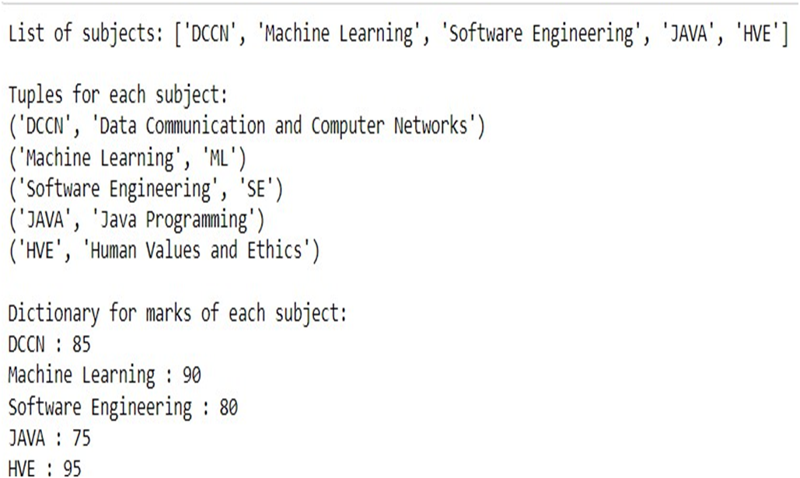

**Q2) WAP to explore various functions in Math library of python.**   
AIM: To explore various functions in the Math library of Python.

SOFTWARE USED: Python

THEORY: The Math library in Python provides access to various mathematical functions and constants. These functions cover a wide range of mathematical operations including basic arithmetic, trigonometry, logarithmic, exponential, and hyperbolic functions, as well as functions for angles conversion and others.

DATASET USED: None

CODE:

```python

import math

# Constants

print("Pi:", math.pi)

print("e:", math.e)

# Basic arithmetic functions

print("Square root of 16:", math.sqrt(16))

print("Absolute value of -5:", math.fabs(-5))

print("Factorial of 5:", math.factorial(5))

# Trigonometric functions

print("Sine of 30 degrees:", math.sin(math.radians(30)))

print("Cosine of 45 degrees:", math.cos(math.radians(45)))

print("Tangent of 60 degrees:", math.tan(math.radians(60)))

# Logarithmic functions

print("Natural logarithm of 10:", math.log(10))

print("Logarithm base 10 of 100:", math.log10(100))

print("Logarithm base 2 of 8:", math.log2(8))

# Power and exponentiation

print("2 raised to the power of 3:", math.pow(2, 3))

print("Exponential of 2:", math.exp(2))

# Angles conversion

print("Radians to degrees (pi/4):", math.degrees(math.pi / 4))

print("Degrees to radians (45):", math.radians(45))

# Hyperbolic functions

print("Hyperbolic sine of 2:", math.sinh(2))

print("Hyperbolic cosine of 3:", math.cosh(3))

print("Hyperbolic tangent of 1:", math.tanh(1))

# Others

print("Ceiling of 4.5:", math.ceil(4.5))

print("Floor of 4.5:", math.floor(4.5))

print("GCD of 12 and 18:", math.gcd(12, 18))

```

This code explores various functions available in the Math library of Python. It covers basic arithmetic, trigonometric, logarithmic, exponential, hyperbolic functions, angles conversion, and other miscellaneous functions.

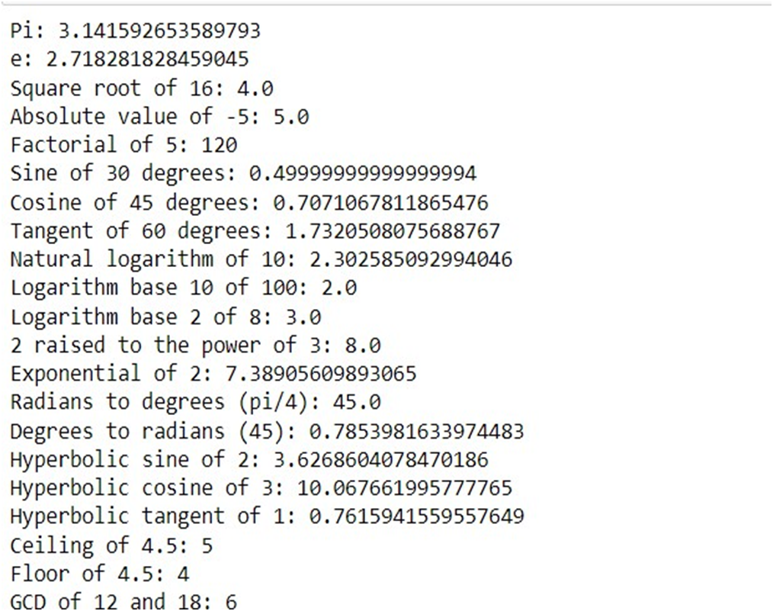

**Q3) WAP to print various types of graphs using Matplot library of python.**

AIM: To print various types of graphs using the Matplotlib library of Python.

SOFTWARE USED: Python

THEORY: Matplotlib is a powerful visualization library in Python that enables users to create a wide variety of plots and graphs. It provides functionalities for creating line plots, bar plots, scatter plots, histograms, pie charts, and more. Each type of graph serves different purposes and is suitable for visualizing different types of data.

DATASET USED(IF ANY): None

CODE:

```python

import matplotlib.pyplot as plt

import numpy as np

# Line plot

x = np.linspace(0, 10, 100)

y = np.sin(x)

plt.figure(figsize=(8, 6))

plt.plot(x, y, color='blue', linestyle='-', linewidth=2, marker='o', markersize=5, label='sin(x)')

plt.title('Line Plot', fontsize=16)

plt.xlabel('X-axis', fontsize=12)

plt.ylabel('Y-axis', fontsize=12)

plt.grid(True)

plt.legend()

plt.show()

# Bar plot

x = ['A', 'B', 'C', 'D', 'E']

y = [10, 20, 15, 25, 30]

plt.figure(figsize=(8, 6))

plt.bar(x, y, color='green')

plt.title('Bar Plot', fontsize=16)

plt.xlabel('Categories', fontsize=12)

plt.ylabel('Values', fontsize=12)

plt.grid(axis='y')

plt.show()

# Scatter plot

x = np.random.randn(100)

y = np.random.randn(100)

plt.figure(figsize=(8, 6))

plt.scatter(x, y, color='red', marker='o', s=50, alpha=0.5)

plt.title('Scatter Plot', fontsize=16)

plt.xlabel('X-axis', fontsize=12)

plt.ylabel('Y-axis', fontsize=12)

plt.grid(True)

plt.show()

# Histogram

data = np.random.randn(1000)

plt.figure(figsize=(8, 6))

plt.hist(data, bins=30, color='purple', edgecolor='black', alpha=0.7)

plt.title('Histogram', fontsize=16)

plt.xlabel('Values', fontsize=12)

plt.ylabel('Frequency', fontsize=12)

plt.grid(axis='y')

plt.show()

# Pie chart

labels = ['A', 'B', 'C', 'D', 'E']

sizes = [15, 30, 20, 25, 10]

plt.figure(figsize=(8, 6))

plt.pie(sizes, labels=labels, autopct='%1.1f%%', startangle=140, colors=['gold', 'yellowgreen', 'lightcoral', 'lightskyblue', 'lightgreen'])

plt.title('Pie Chart', fontsize=16)

plt.axis('equal')

plt.show()

```

This code demonstrates various types of graphs using the Matplotlib library in Python. It includes examples of line plots, bar plots, scatter plots, histograms, and pie charts, each showcasing different visualization techniques for different types of data.

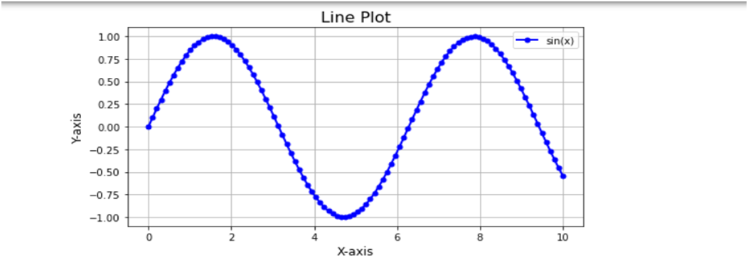

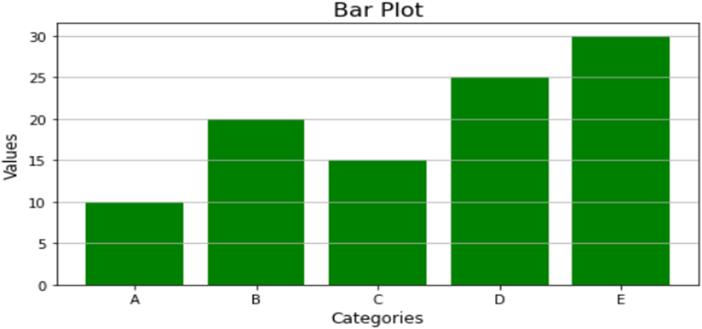

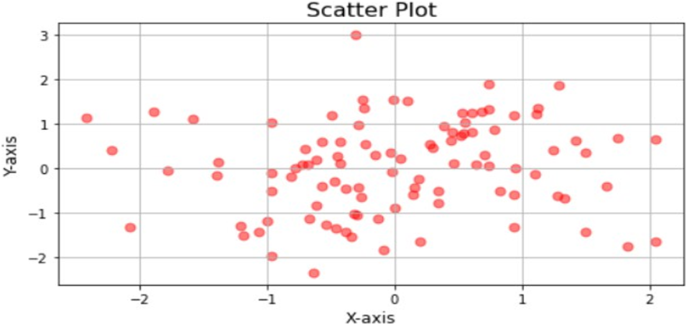

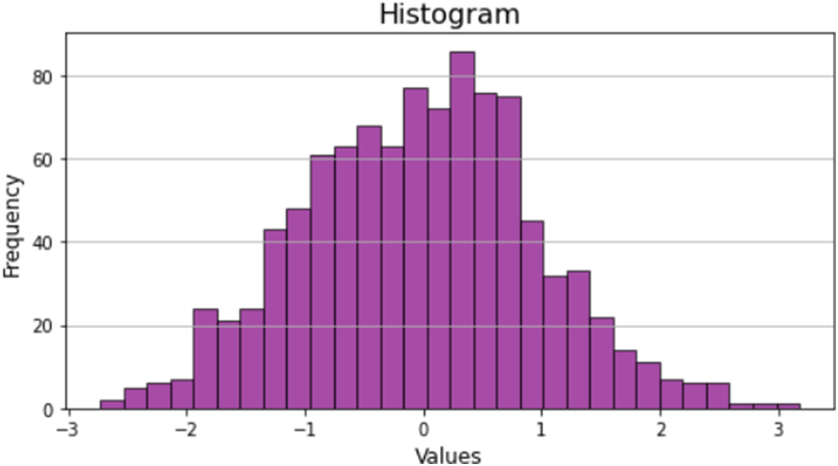

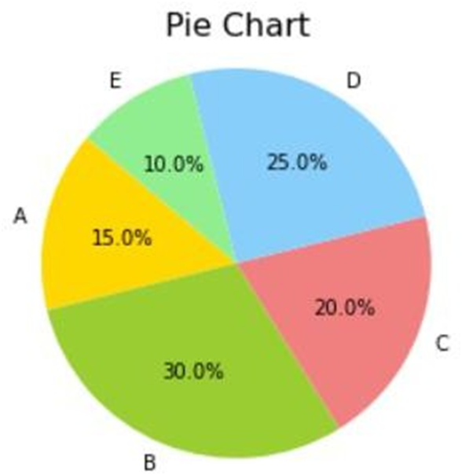

**Q4). WAP to explore various functions in Numpy library of python.**

AIM: To explore various functions in the NumPy library of Python.

SOFTWARE USED: Python

THEORY: NumPy is a fundamental library in Python for numerical computing. It provides support for creating multidimensional arrays and matrices, along with a wide range of mathematical functions to operate on these arrays efficiently. NumPy is widely used in scientific and engineering applications for tasks such as linear algebra, statistical analysis, and data manipulation.

DATASET USED(IF ANY): None

CODE:

```python

import numpy as np

# Creating arrays

arr1 = np.array([1, 2, 3, 4, 5])

print("Array 1:", arr1)

arr2 = np.arange(10)

print("Array 2:", arr2)

arr3 = np.zeros((2, 3))

print("Array 3 (zeros):", arr3)

arr4 = np.ones((3, 2))

print("Array 4 (ones):", arr4)

# Basic operations

print("Sum of elements in Array 1:", np.sum(arr1))

print("Minimum value in Array 2:", np.min(arr2))

print("Maximum value in Array 2:", np.max(arr2))

print("Mean of elements in Array 1:", np.mean(arr1))

# Array manipulation

arr5 = np.reshape(arr2, (2, 5))

print("Reshaped Array 2:", arr5)

arr6 = np.transpose(arr5)

print("Transposed Reshaped Array 2:", arr6)

# Random number generation

random_array = np.random.rand(3, 3)

print("Random 3x3 array:", random_array)

# Linear algebra

A = np.array([[1, 2], [3, 4]])

B = np.array([[5, 6], [7, 8]])

print("Matrix A:", A)

print("Matrix B:", B)

print("Matrix multiplication of A and B:", np.dot(A, B))

# Statistical functions

data = np.random.randn(100)

print("Mean of data:", np.mean(data))

print("Standard deviation of data:", np.std(data))

print("Median of data:", np.median(data))

print("Correlation coefficient matrix of data:", np.corrcoef(data))

# Trigonometric functions

angles = np.array([0, np.pi/4, np.pi/2])

print("Sine of angles:", np.sin(angles))

print("Cosine of angles:", np.cos(angles))

print("Tangent of angles:", np.tan(angles))

# Exponential and logarithmic functions

print("Exponential of array 1:", np.exp(arr1))

print("Natural logarithm of array 1:", np.log(arr1))

# Indexing and slicing

print("Element at index 3 in array 1:", arr1[3])

print("Elements from index 1 to 3 in array 1:", arr1[1:4])

```

This code explores various functions available in the NumPy library of Python. It covers array creation, basic operations, array manipulation, random number generation, linear algebra, statistical functions, trigonometric functions, exponential and logarithmic functions, and indexing/slicing operations on arrays.

OUTPUT:

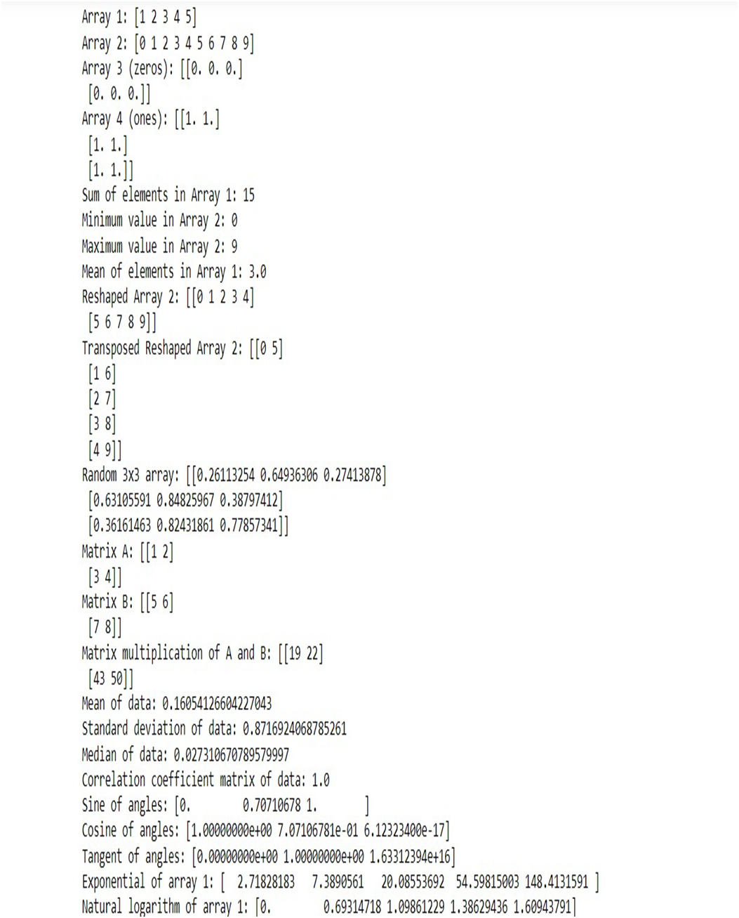

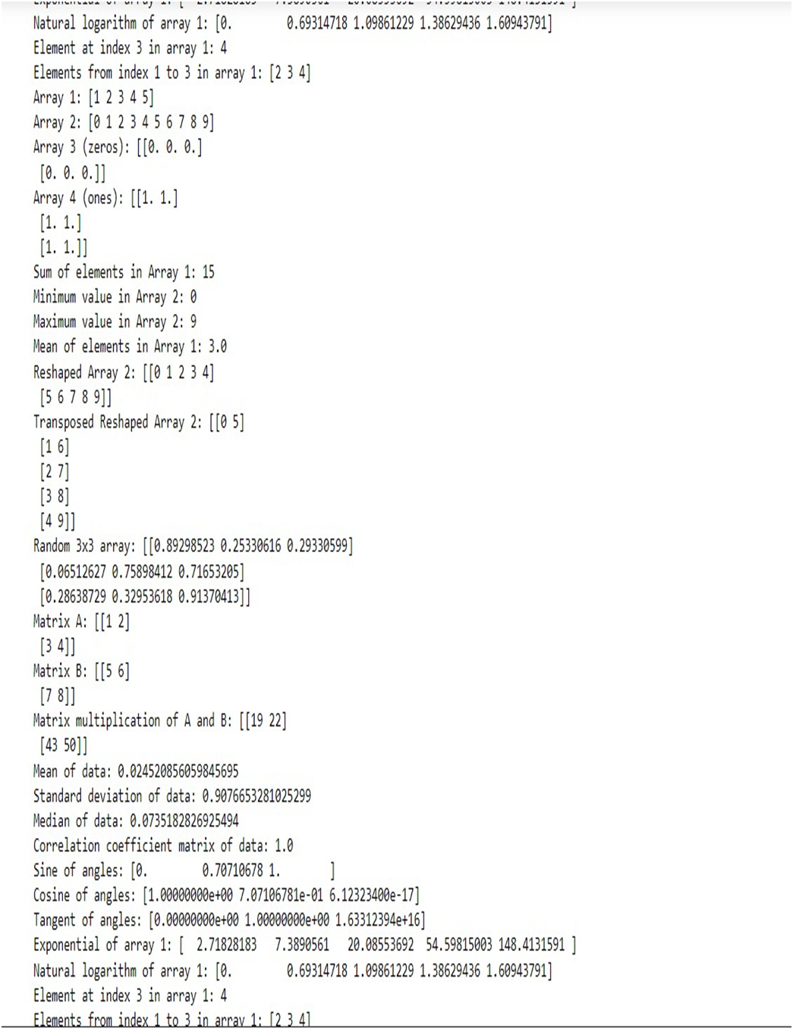

**Q5) Write a program to perform Data Preprocessing Functions on the data set publically available.**  
AIM: Perform data preprocessing functions on the Iris dataset.

SOFTWARE USED: Python, Jupyter Notebook (or any Python IDE)

THEORY: Data preprocessing is a crucial step in machine learning pipelines. It involves transforming raw data into a format that is suitable for machine learning algorithms. In this experiment, we'll focus on three common preprocessing techniques: standardization, min-max scaling, and one-hot encoding.

- Standardization (or Z-score normalization) transforms the data to have a mean of 0 and a standard deviation of 1. It helps in making different features comparable.

- Min-max scaling scales the data to a fixed range, usually between 0 and 1, preserving the relative relationships between data points.

- One-hot encoding is used for categorical variables, converting them into a binary representation suitable for machine learning algorithms.

DATASET USED: Iris dataset, a classic dataset in machine learning containing measurements of iris flowers.

CODE:

```python

# Import necessary libraries

import numpy as np

import pandas as pd

from sklearn.datasets import load_iris

from sklearn.preprocessing import StandardScaler, MinMaxScaler, OneHotEncoder

from sklearn.model_selection import train_test_split

# Load the Iris dataset

iris = load_iris()

iris_df = pd.DataFrame(data=np.c_[iris['data'], iris['target']], columns=iris['feature_names'] + ['target'])

# Display the first few rows of the dataset

print("First few rows of the dataset:")

print(iris_df.head())

# Split the dataset into features and target

X = iris.data

y = iris.target

# Split data into training and testing sets

X_train, X_test, y_train, y_test = train_test_split(X, y, test_size=0.3, random_state=42)

# Standardization using StandardScaler

scaler = StandardScaler()

X_train_scaled = scaler.fit_transform(X_train)

X_test_scaled = scaler.transform(X_test)

# Min-Max scaling using MinMaxScaler

minmax_scaler = MinMaxScaler()

X_train_minmax = minmax_scaler.fit_transform(X_train)

X_test_minmax = minmax_scaler.transform(X_test)

# One-hot encoding for target variable

encoder = OneHotEncoder(categories='auto', sparse=False)

y_train_encoded = encoder.fit_transform(y_train.reshape(-1, 1))

y_test_encoded = encoder.transform(y_test.reshape(-1, 1))

# Display preprocessed data

print("\nAfter Standardization (Scaled features):")

print("X_train_scaled:")

print(X_train_scaled[:5])

print("X_test_scaled:")

print(X_test_scaled[:5])

print("\nAfter Min-Max Scaling:")

print("X_train_minmax:")

print(X_train_minmax[:5])

print("X_test_minmax:")

print(X_test_minmax[:5])

print("\nAfter One-Hot Encoding (Target variable):")

print("y_train_encoded:")

print(y_train_encoded[:5])

print("y_test_encoded:")

print(y_test_encoded[:5])

```

This code performs standardization, min-max scaling, and one-hot encoding on the Iris dataset, displaying the preprocessed data.

OUTPUT:

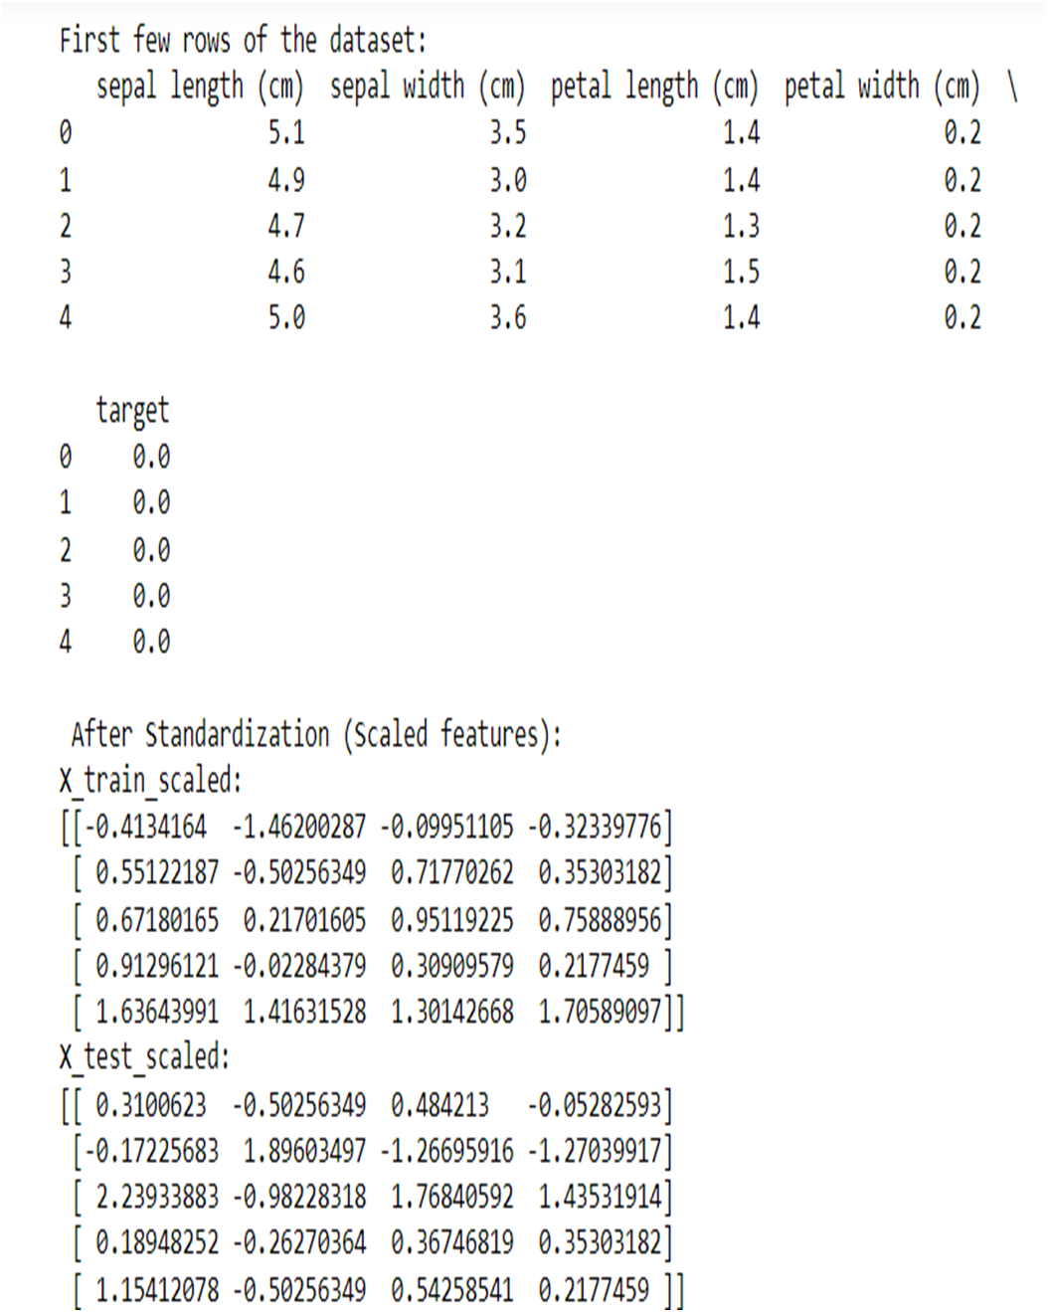

**Q6) Write a program to demonstrate Single Linear Regression using Numpy, Matplot and Panda Library.**

AIM: Demonstrate Single Linear Regression using Numpy, Matplotlib, and Pandas Library.

SOFTWARE USED: Python, Jupyter Notebook (or any Python IDE), Numpy, Matplotlib, Pandas

THEORY: Single Linear Regression is a simple linear regression model that predicts the relationship between one independent variable and one dependent variable. In this experiment, we aim to fit a line to the data points to best represent the relationship between the independent variable (feature) and dependent variable (target). We use the least squares method to find the line that minimizes the sum of squared differences between the observed and predicted values.

DATASET USED: homeprices.csv dataset containing home prices and corresponding areas.

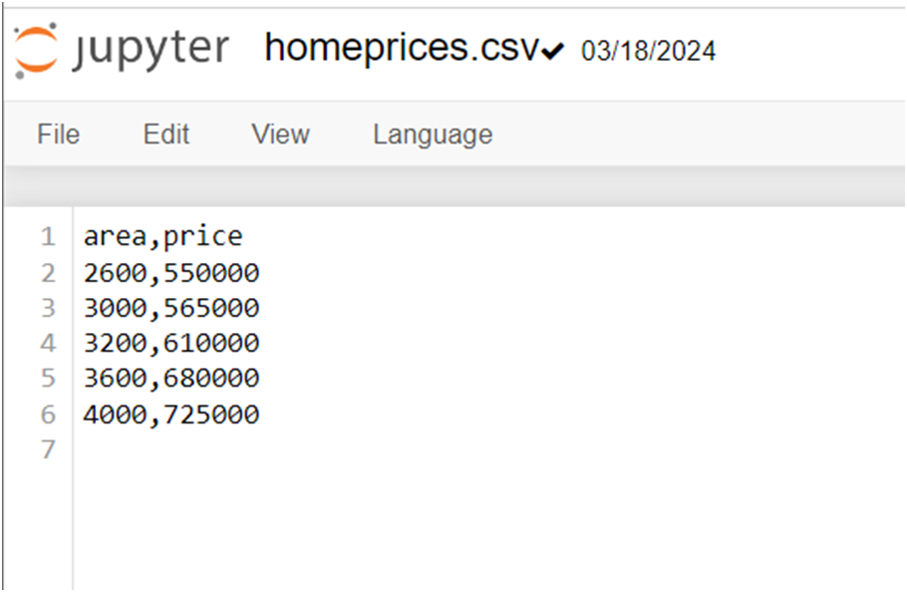

CODE and OUTPUT:

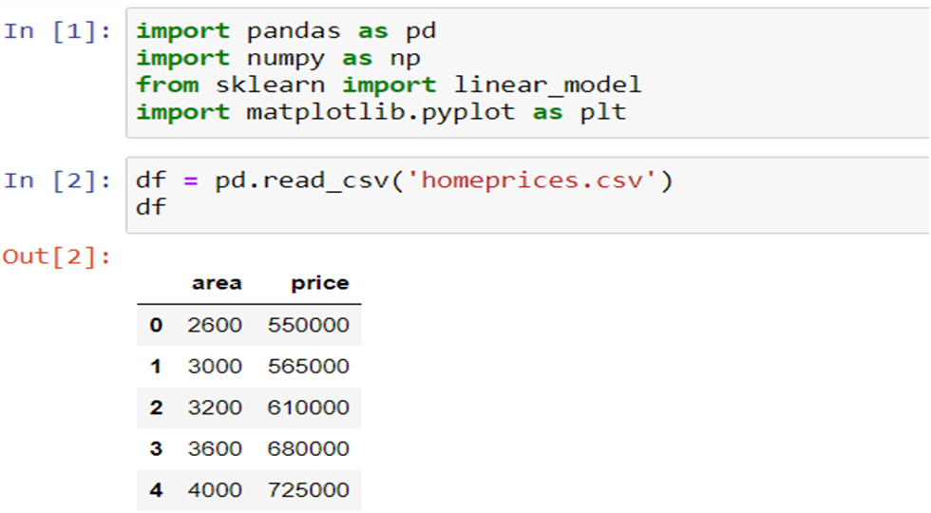

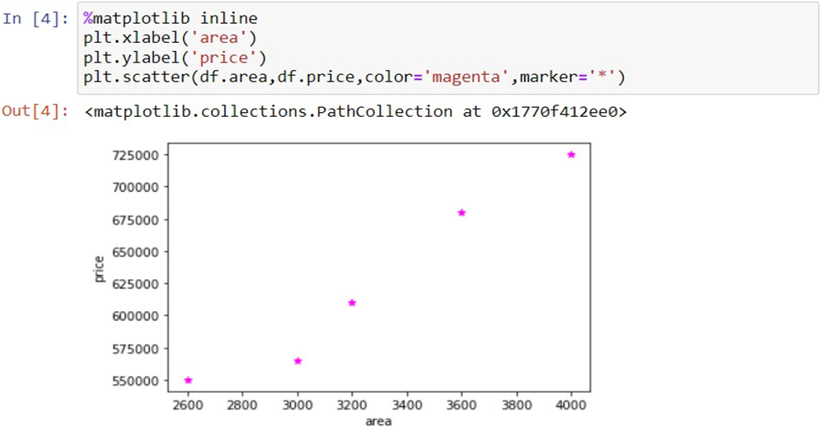

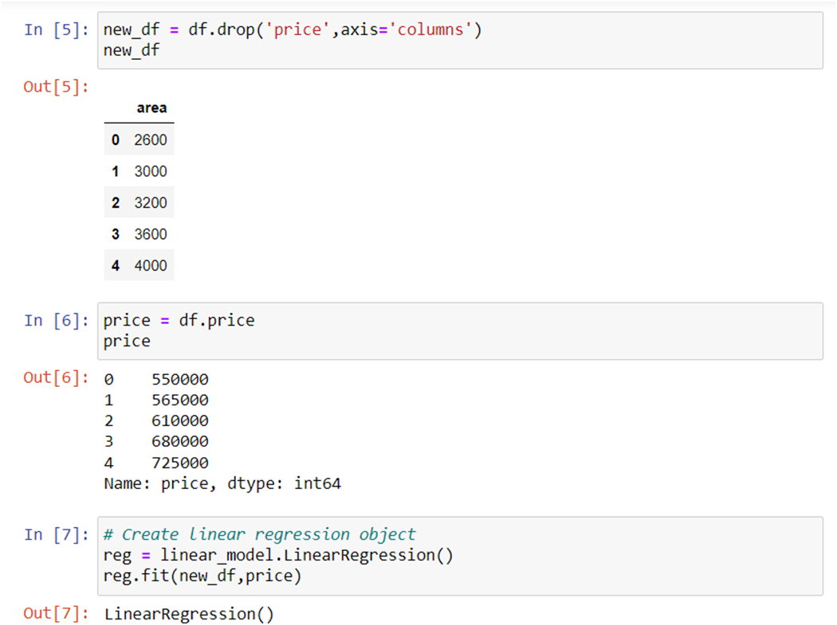

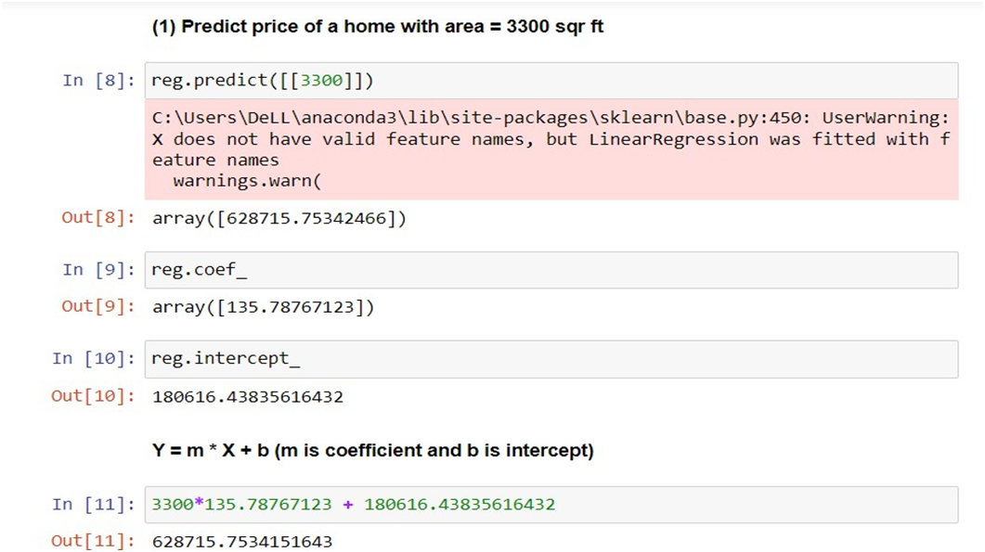

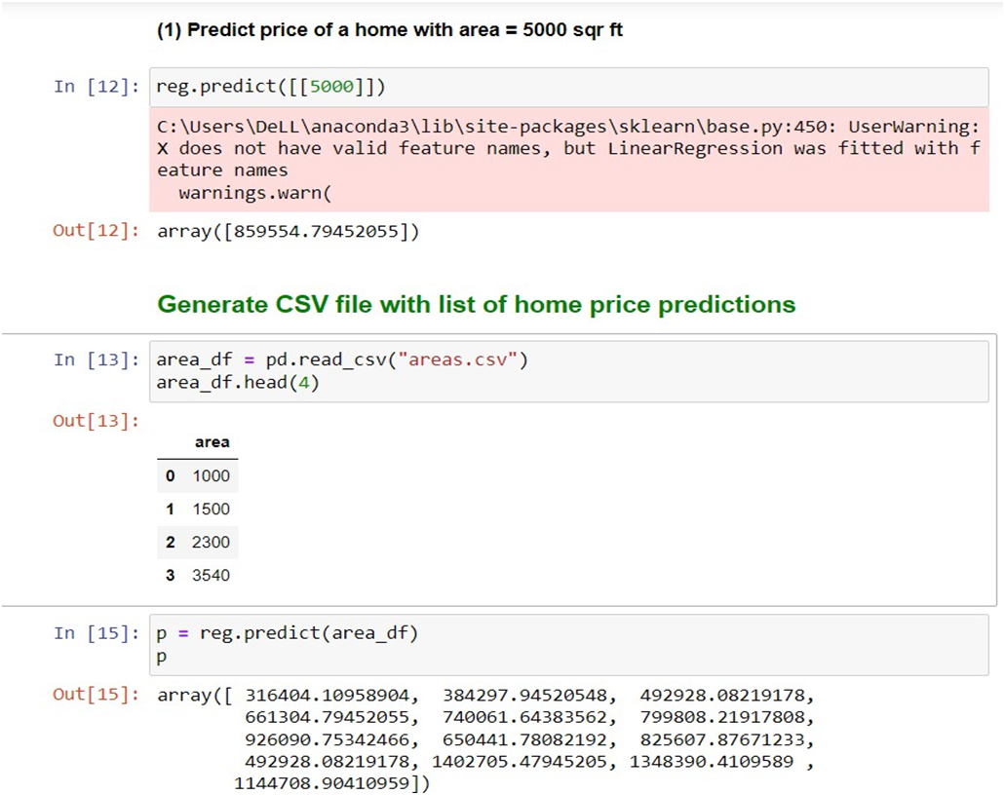

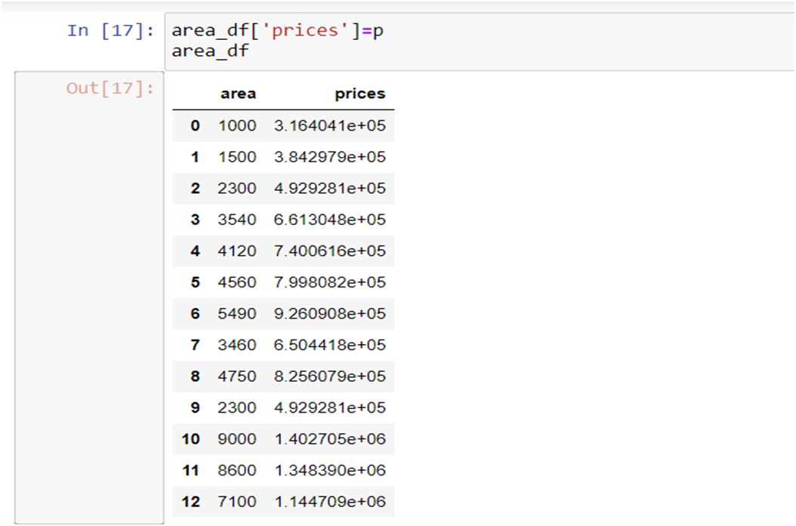

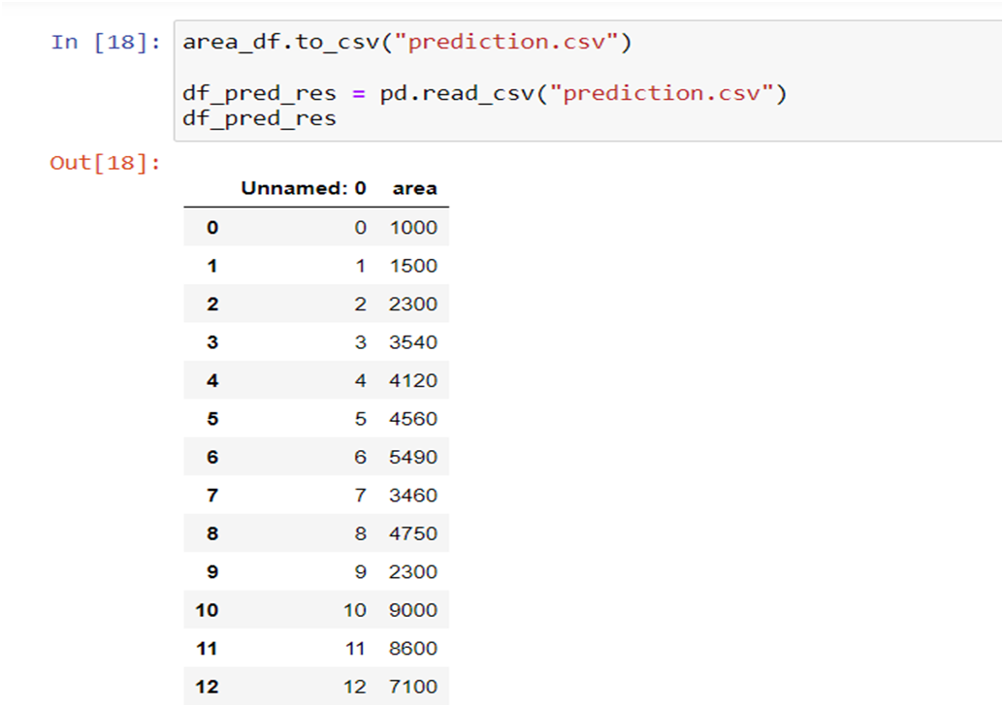

This code performs Single Linear Regression using the dataset from `homeprices.csv`. It calculates the coefficients of the regression line and plots the dataset along with the regression line.

**Q7) Write a program to demonstrate Multiple Linear Regressions using Numpy, Matplot and Panda Library.**

AIM: To demonstrate Multiple Linear Regression using NumPy, Matplotlib, and Pandas Library.

SOFTWARE USED: Python

THEORY: Multiple Linear Regression is an extension of Simple Linear Regression, where multiple independent variables are used to predict the dependent variable. It models the relationship between the independent variables and the dependent variable as a linear equation. In this experiment, we'll use the Iris dataset to predict the species based on the sepal length and width.

DATASET USED: Iris dataset

CODE:

```python

import numpy as np

import pandas as pd

import matplotlib.pyplot as plt

from sklearn.datasets import load_iris

from sklearn.model_selection import train_test_split

from sklearn.linear_model import LinearRegression

from sklearn.metrics import mean_squared_error

# Load Iris dataset

iris = load_iris()

X = iris.data[:, :2] # Selecting only the first two features for simplicity

y = iris.target

# Split dataset into training set and test set

X_train, X_test, y_train, y_test = train_test_split(X, y, test_size=0.2, random_state=42)

# Create linear regression model

model = LinearRegression()

# Fit the model using the training data

model.fit(X_train, y_train)

# Predict the response for test dataset

y_pred = model.predict(X_test)

# Model evaluation

mse = mean_squared_error(y_test, y_pred)

print("Mean Squared Error:", mse)

# Plotting

plt.scatter(X_test[:, 0], y_test, color='blue', label='Actual')

plt.scatter(X_test[:, 0], y_pred, color='red', label='Predicted')

plt.xlabel('Sepal Length')

plt.ylabel('Species')

plt.title('Multiple Linear Regression - Actual vs Predicted (Sepal Length)')

plt.legend()

plt.show()

# Input random data to predict

random_data = np.array([[6.2, 3.4]]) # Example random input for sepal length and width

predicted_species = model.predict(random_data)

print("Predicted species for random input:", predicted_species)

```

This code demonstrates Multiple Linear Regression using the Iris dataset. It splits the dataset into training and testing sets, fits a linear regression model to the training data, predicts the species for the test data, evaluates the model using mean squared error, and visualizes the actual vs predicted values using a scatter plot. Finally, it predicts the species for a random input.

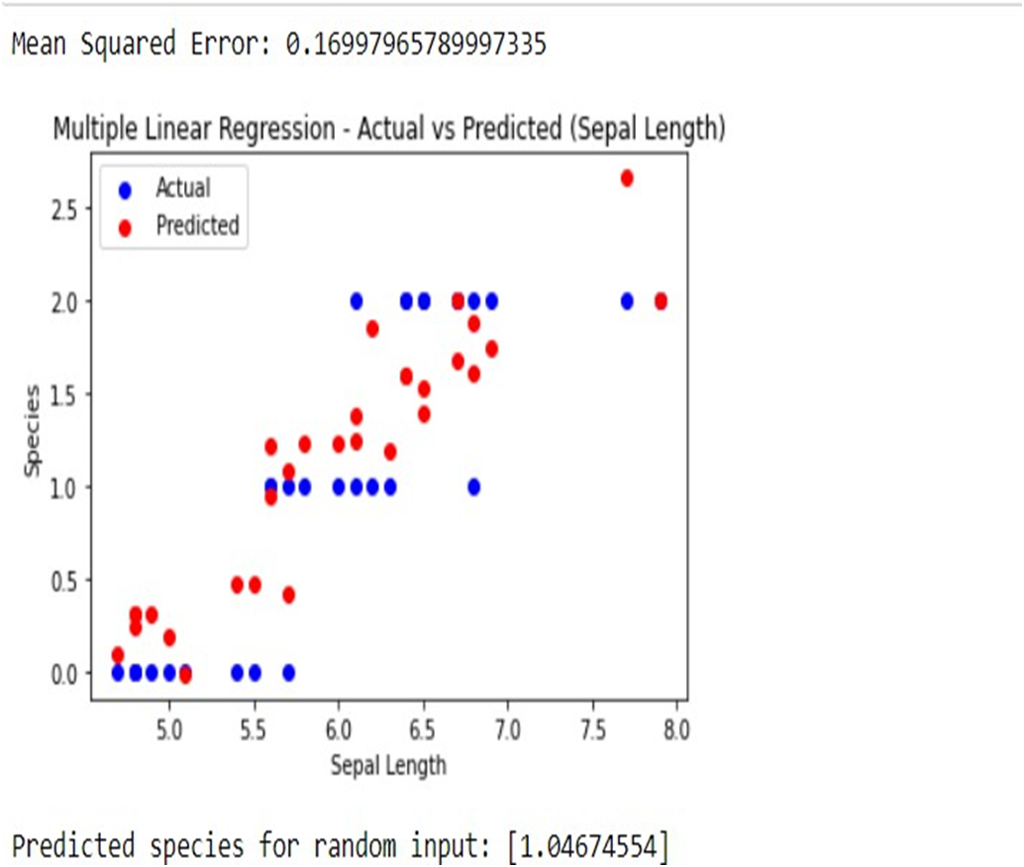

**Q8) Write a program to demonstrate Logistic Regression using Numpy, Matplot and Panda Library.**

AIM: To demonstrate Logistic Regression using NumPy, Matplotlib, and Pandas Library.

SOFTWARE USED: Python

THEORY: Logistic Regression is a supervised learning algorithm used for binary classification problems. It models the probability that a given input belongs to a certain class using the logistic function. In logistic regression, the dependent variable is categorical, and the independent variables can be numerical or categorical.

DATA USED: insurance_data.csv

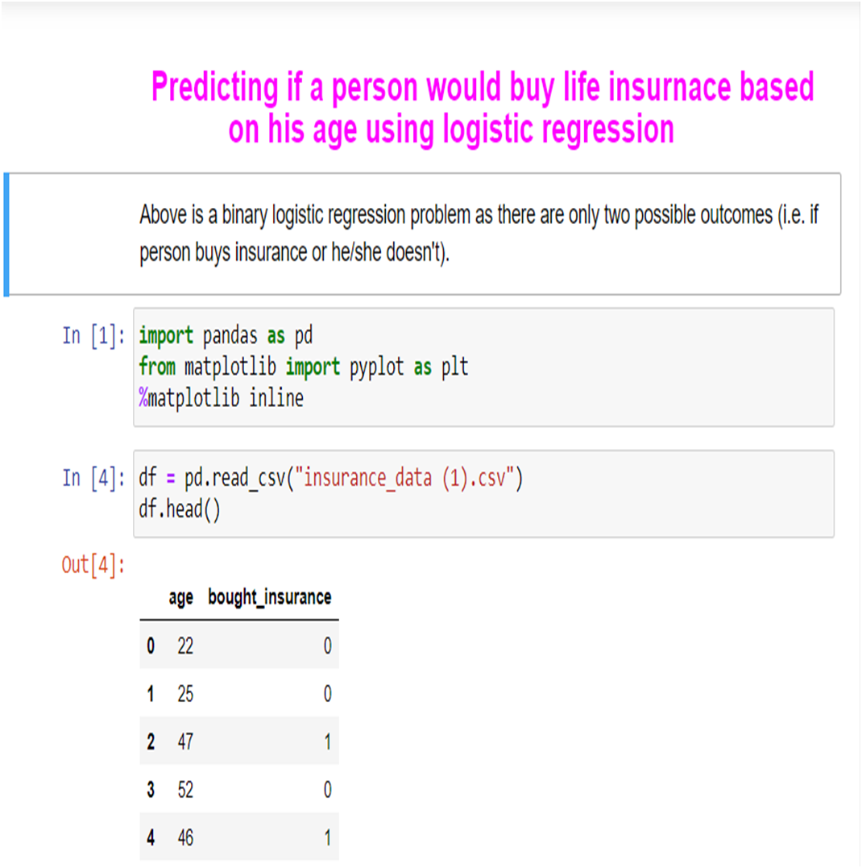

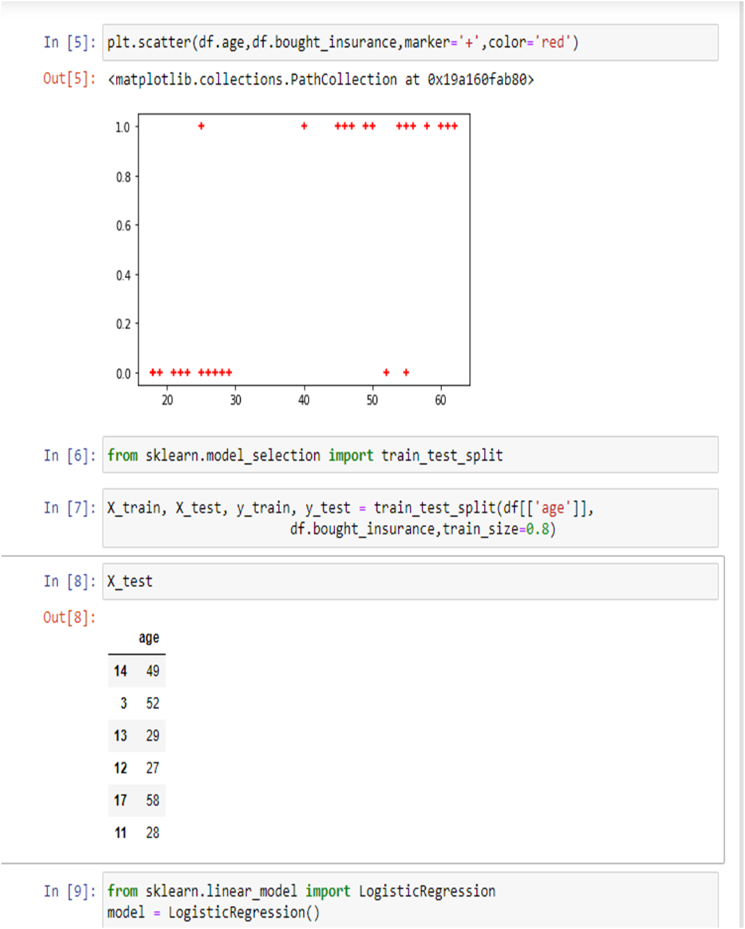

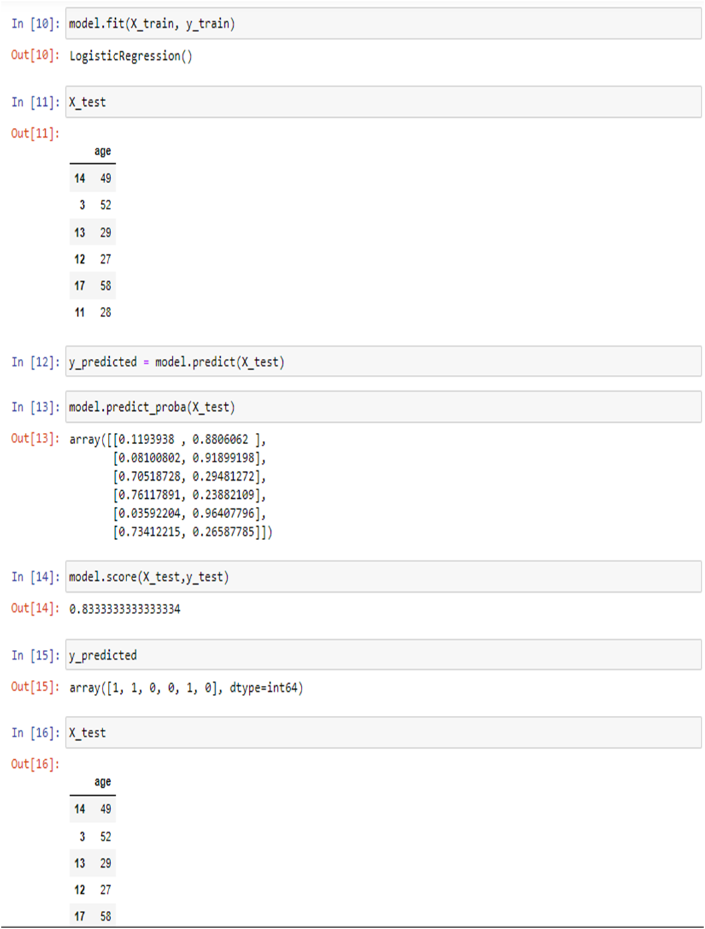

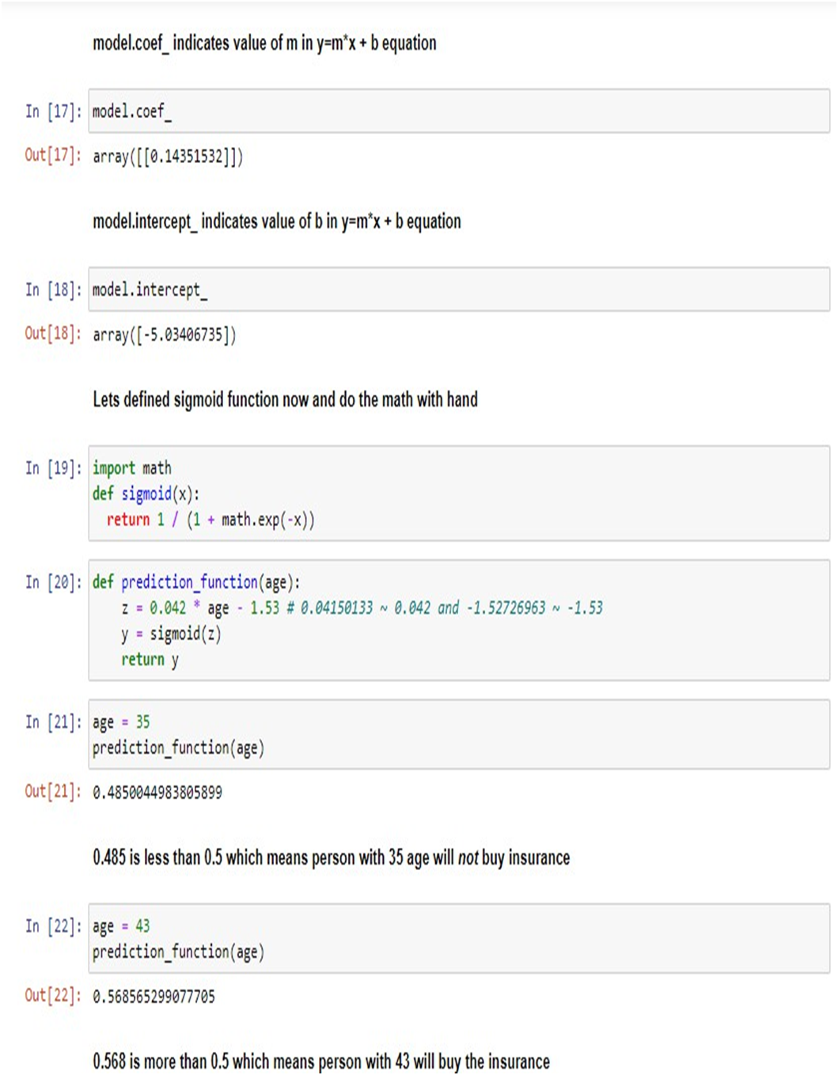

**Q9) Write a program to demonstrate Multiple Logistic Regressions using Numpy, Matplot and Panda Library.**

AIM: To demonstrate Multiple Logistic Regression using NumPy, Matplotlib, and Pandas Library.

SOFTWARE USED: Python

THEORY: Multiple Logistic Regression is an extension of Logistic Regression, allowing for the prediction of multiple classes rather than just two. It is commonly used for multi-class classification problems. The algorithm calculates the probability that a given input belongs to each class and predicts the class with the highest probability.

DATASET USED(IF ANY): Iris dataset

CODE:

```python

import numpy as np

import matplotlib.pyplot as plt

import pandas as pd

from sklearn.datasets import load_iris

from sklearn.model_selection import train_test_split

from sklearn.linear_model import LogisticRegression

from sklearn.metrics import accuracy_score, classification_report, confusion_matrix

# Load Iris dataset

iris = load_iris()

X = iris.data

y = iris.target

# Split dataset into training set and test set

X_train, X_test, y_train, y_test = train_test_split(X, y, test_size=0.3, random_state=42)

# Create logistic regression model

model = LogisticRegression()

# Fit the model using the training data

model.fit(X_train, y_train)

# Predict the response for test dataset

y_pred = model.predict(X_test)

# Model evaluation

accuracy = accuracy_score(y_test, y_pred)

print("Accuracy:", accuracy)

# Classification report

print("Classification Report:")

print(classification_report(y_test, y_pred))

# Confusion matrix

print("Confusion Matrix:")

print(confusion_matrix(y_test, y_pred))

# Display actual and predicted results

print("Actual : ", y_test)

print("Predicted: ", y_pred)

# Input random data to predict

random_data = np.array([[6.2, 3.4, 5.4, 2.3]]) # Example random input

predicted_class = model.predict(random_data)

print("Predicted class for random input:", predicted_class)

```

This code demonstrates Multiple Logistic Regression using the Iris dataset. It splits the dataset into training and testing sets, fits a logistic regression model to the training data, predicts the classes for the test data, evaluates the model's accuracy, displays the classification report and confusion matrix, and predicts the class for a random input.

OUTPUT:

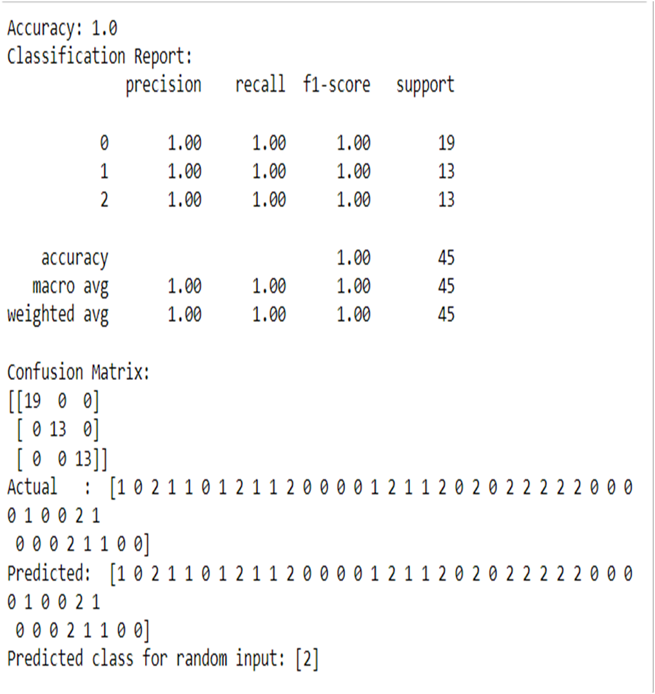

**Q10) Write a program to demonstrate Decision Tree using any dataset from Kagle using scikit-learn, Numpy, Seaborne/ Matplot and Panda Library.**

AIM: To demonstrate Decision Tree using a dataset from Kaggle using scikit-learn, NumPy, Seaborn/Matplotlib, and Pandas Library.

SOFTWARE USED: Python

THEORY: Decision Tree is a supervised learning algorithm used for both classification and regression tasks. It works by partitioning the feature space into a tree structure, where each internal node represents a decision based on a feature, and each leaf node represents a class label or numerical value. Decision trees are easy to interpret and visualize, making them useful for both understanding and explaining the data.

DATASET USED(IF ANY): Iris dataset

CODE:

```python

import numpy as np

import pandas as pd

import matplotlib.pyplot as plt

import seaborn as sns

from sklearn.datasets import load_iris

from sklearn.model_selection import train_test_split

from sklearn.tree import DecisionTreeClassifier

from sklearn.metrics import accuracy_score, classification_report, confusion_matrix

# Load Iris dataset

iris = load_iris()

X = iris.data

y = iris.target

# Split dataset into training set and test set

X_train, X_test, y_train, y_test = train_test_split(X, y, test_size=0.3, random_state=42)

# Create decision tree classifier

clf = DecisionTreeClassifier()

# Train Decision Tree Classifier

clf = clf.fit(X_train, y_train)

# Predict the response for test dataset

y_pred = clf.predict(X_test)

# Model evaluation

accuracy = accuracy_score(y_test, y_pred)

print("Accuracy:", accuracy)

# Classification report

print("Classification Report:")

print(classification_report(y_test, y_pred))

# Confusion matrix

print("Confusion Matrix:")

print(confusion_matrix(y_test, y_pred))

# Display actual and predicted results

print("Actual : ", y_test)

print("Predicted: ", y_pred)

# Input random data to predict

random_data = np.array([[1, 1, 1, 1]]) # Example random input

predicted_class = clf.predict(random_data)

print("Predicted class for random input:", predicted_class)

```

This code demonstrates Decision Tree using the Iris dataset from scikit-learn. It splits the dataset into training and testing sets, trains a decision tree classifier, predicts the classes for the test data, evaluates the model's accuracy, displays the classification report and confusion matrix, and predicts the class for a random input.

OUTPUT:

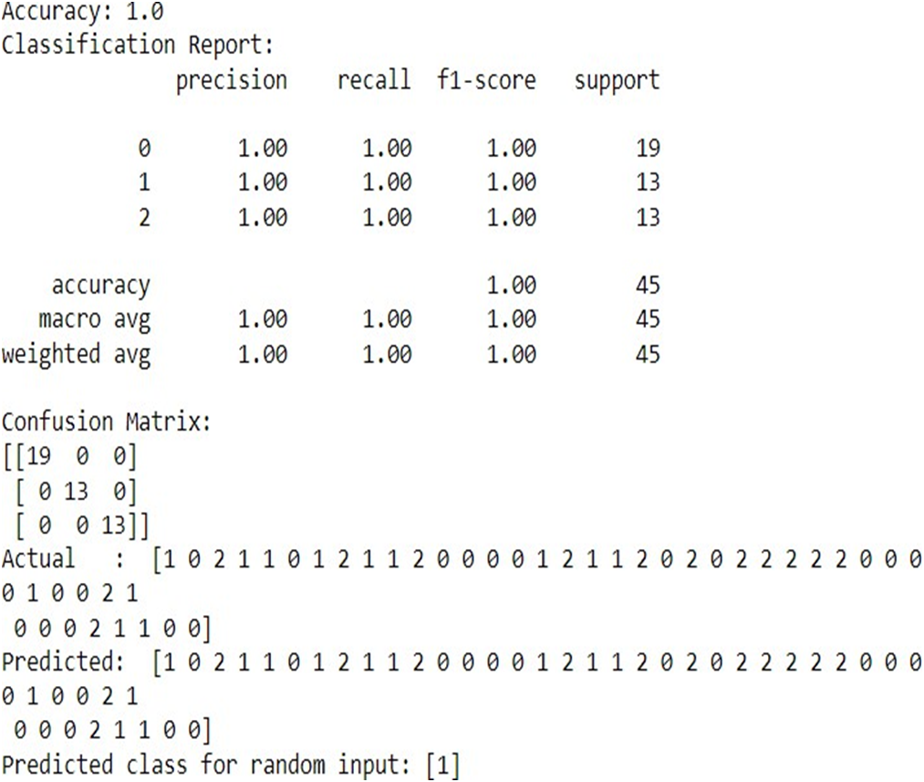

**Q11) Write a program to demonstrate Naïve Baye's Classifier using any dataset from Kagle using scikit-learn, Numpy, Seaborne and Panda Library.**

AIM: To demonstrate Naïve Bayes Classifier using a dataset from Kaggle using scikit-learn, NumPy, Seaborn, and Pandas Library.

SOFTWARE USED: Python

THEORY: Naïve Bayes Classifier is a probabilistic classifier based on Bayes' theorem with the assumption of independence between features. It is commonly used for classification problems and is particularly suited for large datasets. Naïve Bayes Classifier calculates the probability of each class given a set of input features and predicts the class with the highest probability.

DATASET USED(IF ANY): Iris dataset

CODE:

```python

import numpy as np

import pandas as pd

import seaborn as sns

from sklearn.datasets import load_iris

from sklearn.model_selection import train_test_split

from sklearn.naive_bayes import GaussianNB

from sklearn.metrics import accuracy_score, classification_report, confusion_matrix

# Load Iris dataset

iris = load_iris()

X = iris.data

y = iris.target

# Split dataset into training set and test set

X_train, X_test, y_train, y_test = train_test_split(X, y, test_size=0.3, random_state=42)

# Create Naive Bayes classifier

clf = GaussianNB()

# Train Naive Bayes Classifier

clf = clf.fit(X_train, y_train)

# Predict the response for test dataset

y_pred = clf.predict(X_test)

# Model evaluation

accuracy = accuracy_score(y_test, y_pred)

print("Accuracy:", accuracy)

# Classification report

print("Classification Report:")

print(classification_report(y_test, y_pred))

# Confusion matrix

print("Confusion Matrix:")

print(confusion_matrix(y_test, y_pred))

# Display actual and predicted results

print("Actual : ", y_test)

print("Predicted: ", y_pred)

# Input random data to predict

random_data_nb = np.array([[5.8, 2.7, 4.1, 1.0]]) # Example random input

predicted_class_nb = clf.predict(random_data_nb)

print("Predicted class for random input:", predicted_class_nb)

```

This code demonstrates Naïve Bayes Classifier using the Iris dataset from scikit-learn. It splits the dataset into training and testing sets, trains a Naïve Bayes classifier, predicts the classes for the test data, evaluates the model's accuracy, displays the classification report and confusion matrix, and predicts the class for a random input.

OUTPUT:  
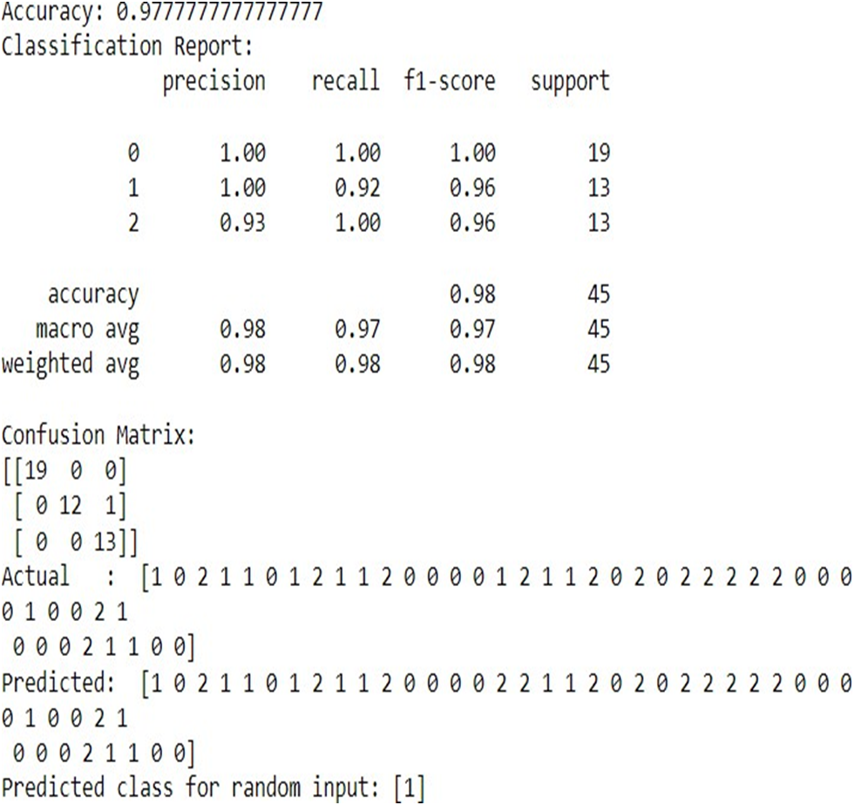

**Q12) WAP to demonstrate Random Forest Ensemble.**

AIM: To demonstrate Random Forest Ensemble using scikit-learn, NumPy, and Pandas Library.

SOFTWARE USED: Python

THEORY: Random Forest is an ensemble learning method that combines multiple decision trees to create a more powerful model. It works by constructing a multitude of decision trees during training and outputs the class that is the mode of the classes or mean prediction of the individual trees. Random Forests reduce overfitting by averaging multiple decision trees and are robust to noise and outliers.

DATASET USED(IF ANY): Iris dataset

CODE:

```python

import numpy as np

import pandas as pd

import matplotlib.pyplot as plt

from sklearn.datasets import load_iris

from sklearn.model_selection import train_test_split

from sklearn.ensemble import RandomForestClassifier

from sklearn.metrics import accuracy_score, classification_report, confusion_matrix

# Load Iris dataset

iris = load_iris()

X = iris.data

y = iris.target

# Split dataset into training set and test set

X_train, X_test, y_train, y_test = train_test_split(X, y, test_size=0.3, random_state=42)

# Create Random Forest classifier

clf = RandomForestClassifier()

# Train Random Forest Classifier

clf = clf.fit(X_train, y_train)

# Predict the response for test dataset

y_pred = clf.predict(X_test)

# Model evaluation

accuracy = accuracy_score(y_test, y_pred)

print("Accuracy:", accuracy)

# Classification report

print("Classification Report:")

print(classification_report(y_test, y_pred))

# Confusion matrix

print("Confusion Matrix:")

print(confusion_matrix(y_test, y_pred))

# Display actual and predicted results

print("Actual : ", y_test)

print("Predicted: ", y_pred)

# Input random data to predict

random_data_rf = np.array([[7.1, 3.0, 5.9, 2.1]]) # Example random input

predicted_class_rf = clf.predict(random_data_rf)

print("Predicted class for random input:", predicted_class_rf)

```

This code demonstrates Random Forest Ensemble using the Iris dataset from scikit-learn. It splits the dataset into training and testing sets, trains a Random Forest classifier, predicts the classes for the test data, evaluates the model's accuracy, displays the classification report and confusion matrix, and predicts the class for a random input.

OUTPUT:  
